Do you have a well or spring?
Do you wonder about your water quality?

Our water testing includes bacteria, lead, arsenic, and 11 other contaminants that may cause health problems or make your water taste or smell bad.

The Virginia Household Water Quality program offers affordable water testing and education to improve the water quality and health of Virginians who rely on wells and springs.

Pick up your kit – Drop off your samples – Receive your results – Understand what to do

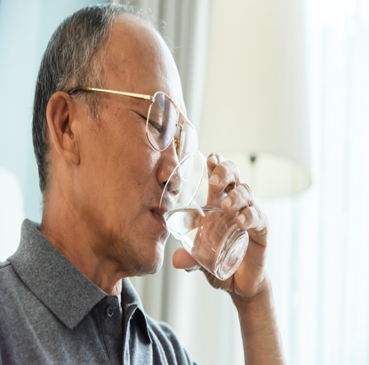
Contact: NAME; EMAIL; PHONE

 | Date and Time | Location
Pick up sample kit and receive directions to collect samples | June 16 6 pm | 755 Roanoke St Christiansburg
Drop off samples | June 18, 8 – 10 am | 755 Roanoke St Christiansburg
Results will be mailed or emailed | July 17

How much does it cost? $70 per sample kit.

Testing includes: bacteria, lead, copper, arsenic, iron, manganese, pH, hardness, sodium, sulfate, fluoride, and nitrate.

If you are a person with a disability and desire any assistive devices, services or other accommodations to participate in this activity, please contact NAME at PHONE during business hours of 9 a.m. and 5 p.m. to discuss accommodations 5 days prior to the event. *TDD number is (800) 828-1120.
Refunds are available minus a $5 processing fee, if the refund request is received by the sample drop off date. All refunds will incur a $5 processing fee.

