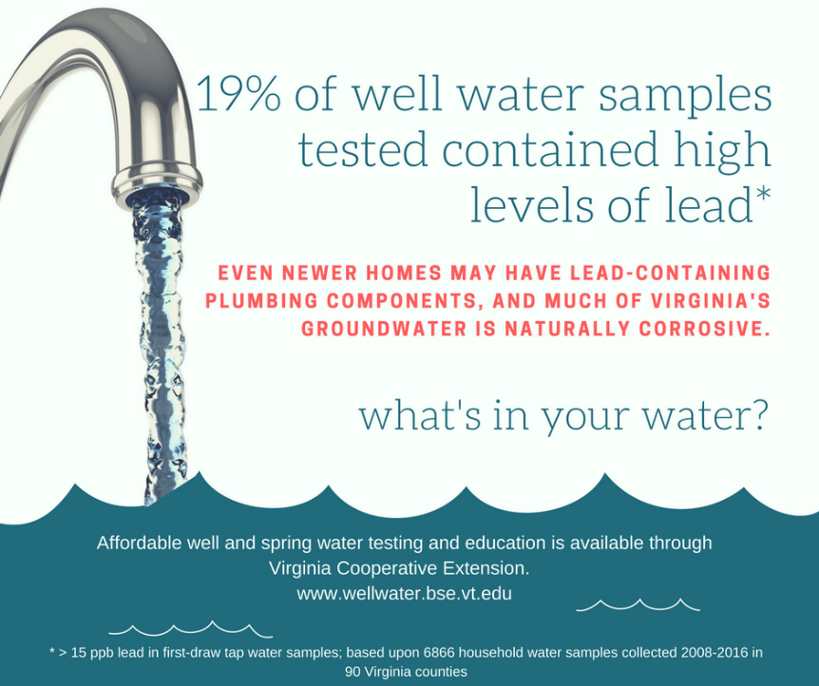

The Virginia Household Water Quality Program offers affordable, confidential water testing for people who rely on private wells and springs.
Pick up your sample kit | Drop off your water samples | Get your results
Date  Time  Address | Date  Time  Address | Date  Time  Address

Testing includes: bacteria, lead, copper, arsenic, iron, manganese, pH, hardness, sodium, sulfate, fluoride, and nitrate.

Cost is $70 per sample kit.

Contact: NAME; EMAIL; PHONE; registration link

If you are a person with a disability and desire any assistive devices, services or other accommodations to participate in this activity, please contact NAME at PHONE during business hours of 9 a.m. and 5 p.m. to discuss accommodations 5 days prior to the event. *TDD number is (800) 828-1120.
Refunds are available minus a $5 processing fee, if the refund request is received by the sample drop off date. All refunds will incur a $5 processing fee.

