The Virginia Household Water Quality Program aims to improve the water quality and health of Virginians with wells, springs and cisterns. We provide affordable water testing, help interpreting their water test results, and information about addressing problems.
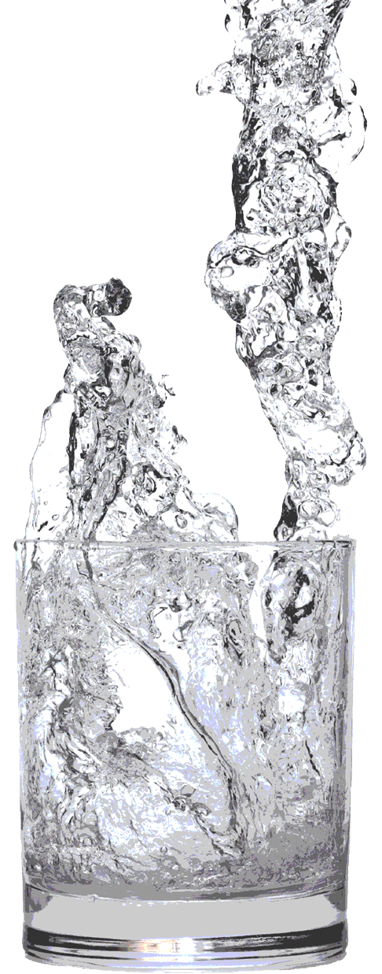
How does it work?
Participants attend a short Kickoff Meeting, where they receive information about how to collect water samples and a sampling kit. Participants collect samples on a designated day and time and drop off at the sample collection point. Water is analyzed on the Virginia Tech campus for 14 parameters. Once analysis is complete, results are returned at a final meeting, water test results are explained, along with information about how to deal with any problems. If you are unable to attend the interpretation meeting, results will be mailed to you.

Testing includes:
Iron | Manganese | Sulfate | Hardness
Sodium | Copper | Nitrate | Arsenic
Fluoride | pH | Total Dissolved Solids
Coliform bacteria | E. coli bacteria | Lead
Cost: $60 per sample kit. Checks and cash accepted. Make checks payable to XXX.

 | Location 1 | Location 2 | Location 3
Pick up kit | Date and Time | Date and Time | Date and Time
Drop off samples | Date and Time | Date and Time | Date and Time
Results meeting | Date and Time | Date and Time | Date and Time

Contact CONTACT NAME to register: EMAIL@VT.EDU or PHONE
For more information about the program, visit http://www.wellwater.bse.vt.edu/

If you are a person with a disability and desire any assistive devices, services or other accommodations to participate in this activity, please contact NAME at PHONE during business hours of 9 a.m. and 5 p.m. to discuss accommodations 5 days prior to the event. *TDD number is (800) 828-1120.

