Workshop

Virginia Household Water Quality Program
Montgomery County Drinking Water Clinic

Do you have a well or spring and wonder if your water is safe to drink?
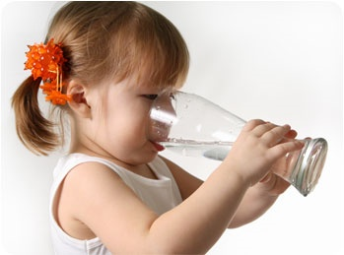

The Virginia Household Water Quality program offers affordable water testing and education to improve the water quality and health of Virginians who rely on private wells and springs.

How much does it cost? $70 per sample kit.

Testing includes: bacteria, lead, copper, arsenic, iron, manganese, pH, hardness, sodium, sulfate, fluoride, and nitrate.
 | Date and Time | Location
Pick up sample kit | June 16 6 pm | 755 Roanoke St Christiansburg
Drop off samples | June 18, 8 – 10 am | 755 Roanoke St Christiansburg
Results will be mailed or emailed | July 17

If you are a person with a disability and desire any assistive devices, services or other accommodations to participate in this activity, please contact NAME at PHONE during business hours of 9 a.m. and 5 p.m. to discuss accommodations 5 days prior to the event. *TDD number is (800) 828-1120.
Refunds are available minus a $5 processing fee, if the refund request is received by the sample drop off date. All refunds will incur a $5 processing fee.

REGISTER : (add link)

or contact
Meredith Hoggatt
mhoggatt@vt.edu
540-382-5790

